
Southern California Edison
CSRP
1087 E-CIM-CS-02 Create Work Order During Move-In/Move-Out/Transfer
Customer Interaction Management
Functional Specification
Version 0.6

File Name: E-CIM-CS-02 Create Work Order During Move-In/Move-Out/Transfer
Created Date: June 14, 2018
Version Saved: June 14, 2018

Table of Contents

1 Purpose and Overview 7
1.1 Description of the Enhancement 7
1.2 Summary of the development 7
1.2.1 File Naming Convention 7
1.2.2 APSE Location 7
1.3 Responsible Parties 7
1.4 Document Control 8
1.5 Terminology 8
1.6 Specification Type 8
2 Scope Summary 10
2.1 High Level Business Requirements 10
2.1.1 Impacted Role(s) 10
2.1.2 Linked Requirement(s) 10
2.2 Overview of Solution 11
2.3 Assumptions 13
2.4 Key Considerations 13
2.4.1 Design Principles, Important Comments / Considerations 13
2.4.2 Performance Considerations (Performance/ Volume test requirements) 14
2.4.3 Open Issues 14
2.4.4 Risks 14
2.4.5 Reference Programs 14
2.4.6 Dependency on Other Development or Interface 14
2.4.7 Systems Involved 14
2.4.8 Link to Design / Decision Paper or Process Design Document 14
3 Business Details 15
3.1 Volume of Data 15
3.2 Line of Business (LOB) Specific Considerations 15
3.3 Language Considerations 15
3.4 Internal Controls / SOX Considerations 15
3.5 Authorizations 15
3.6 Cross Work Stream Impact 15
3.7 Regression Impacts 15
3.8 Archiving Compatibility 15
3.9 Cybersecurity Considerations 15
4 Scope of the Development – Form 16
4.1 Output 16
4.1.1 Form type 16
4.1.2 Legal / Regulatory Form 16
4.1.3 Internal / External Usage 16
4.1.4 Template Definition 16
4.1.5 Layout Details / Sample Formats 16
4.1.6 Business Logic for Data Retrieval 16
4.1.7 Input Parameter 16
4.1.8 Triggering Mechanism 16
4.1.9 Back Page 16
4.1.10 Enclosure 16
4.1.11 Special Considerations 16
4.1.12 Error Handling 17
4.1.13 Document OPENTEXT Archive requirement 17
4.2 Special Printing Considerations 17
4.2.1 Printed Output 17
4.2.2 Page Size 17
4.2.3 Page Orientation 17
4.2.4 Multiple pages 17
4.2.5 Duplex Printing 17
4.2.6 Bulk printing 17
4.2.7 Retained output 17
4.2.8 Envelope stuffing 17
5 Scope of the Development – Report 20
5.1 [ABAP / BI / ECC Query] Report – [Description] 20
5.1.1 Legacy Report Information 20
5.1.2 Description 20
5.1.3 Business Logic 20
5.1.4 Key Business Questions Answered 20
5.1.5 Selection Screen 20
5.1.6 Sort / Filters / Grouping 20
5.1.7 Report Fields 20
5.1.8 Chart / Graph Output 20
5.1.9 Output Medium 21
5.1.10 Page Size 21
5.1.11 Page Orientation 21
5.1.12 SAP Transaction(s) 21
5.1.13 Custom Table 21
5.1.13.1 Table Type 21
5.1.13.2 Number of Records 21
5.1.14 User Group 21
5.1.15 Run Mode 21
5.1.16 Error and Success Results 21
5.1.17 Archived Data 21
5.1.18 Security 21
6 Scope of the Development – Interface 22
6.1 Web Service 22
6.1.1 Configuration 22
6.1.2 Development Objects 22
6.1.3 Business Logic 22
6.1.4 Triggering Mechanism 22
6.1.5 Error Handling 22
6.2 Interface – [Description] 22
6.2.1 Changes to non-SAP applications / vendors 22
6.2.2 Input Data / Output Data / File Layout / Field Mapping 22
6.2.3 Field List 22
6.2.4 Selection Screen if Running Interface Manually 23
6.2.5 Business Logic 23
6.2.6 Triggering Mechanism 23
6.2.7 Function Modules / RFCs / BAPIs for Interfaces 23
6.2.8 Error and Success Results 23
6.2.9 Archived Data 23
6.2.10 Security 23
7 Scope of the Development – Enhancement 24
7.1 Complex Development (only if prototyping or large developments) 24
7.1.1 Detailed Process Description 24
7.2 Enhancements 26
7.2.1 SAP Transaction(s) 26
7.2.2 Input Data / Output Data 26
7.2.3 Business Logic 26
7.2.4 User Exits 49
7.2.5 Error Handling 49
7.3 BADI – BP Contacts 49
7.3.1 Business Object 49
7.3.2 Input / Output Parameters 49
7.3.3 Business Logic 49
7.3.4 Error Handling 49
7.4 Data Dictionary Object 49
7.4.1 Custom Table 49
7.4.2 Search helps 49
7.5 Dialog program / Web Developments (BSP / Web Dynpro) / Web IC / C4C Views / C4C Flows 50
7.5.1 Screen Field and Layout Details 50
7.5.2 Screen Sequence 50
7.5.3 Business Logic 50
7.5.4 Custom Tables Updated 50
7.5.5 Error Handling 50
7.5.6 Multi-User Access Consideration 50
7.5.7 Branding Requirements 50
7.5.8 Security 50
8 Scope of the Development – Workflow 52
8.1 Workflow Development 52
8.1.1 Configuration 52
8.1.2 Triggering Mechanism 52
8.1.3 Creation/Change of Workflow 52
8.1.4 Workflow Business Logic 52
8.1.5 Error Handling 52
9 Unit Test 53
9.1 Triggers 53
9.2 Test pre-conditions 53
9.3 Test Data 53
9skype4 Unit Test Specification 53

This page intentionally left blank

Purpose and Overview
The purpose of this document is to specify the background information, the business requirements, the functional design and the scope of the development. This will serve as an input to the technical design; therefore all the relevant sections of this document will be completed. This document will also be used by the Support team for supporting the systems and therefore it should be kept up-to-date throughout the project.
This functional specification will concentrate solely on what is required and not how it can be achieved.

Description of the Enhancement
This functional spec will detail the following enhancements:
- Enhancement on creation of a move-in to create the required service order (when applicable)
- Enhancement on creation of move-out to create the required service order (when applicable)
- Custom Function Module for the BRF+ application
- Batch Program with two processing modes that will be run daily and execute the required AMI disconnections/reconnections.
  - Move-Out Disconnections
  - Move-In Reconnections

Summary of the development
Development Type | E
Business Process | CIM-CS-02
Development ID | 1087
Title | E-CIM-CS-02 Create Work Order During Move-In/Move-Out/Transfer

File Naming Convention
The specification will follow this naming convention and will be updated to reflect the new version number as defined in the Document Control section whenever the spec is updated:
FS [Development Type] [Business Process] [Development ID] [Title] [v#.#]

APSE Location
This functional specification can be located within the APSE for SCE by selecting this link:
E-CIM-CS-02 Create Work Order During Move-In/Move-Out/Transfer

Responsible Parties
Contact | Contact Person
Southern California Edison Business Process Owner | Janet Covington
Southern California Edison Lead | Christine Evans
HCL Functional Lead | Adrianus Halim
Solution Architect | Pedro Ferreira da Costa
Front Office or Back Office Lead | Christina Evans
Subject Matter Experts | Cari Young, Ernesto Valle
Key User Group | CCC

Document Control
Version | Description of Change | Date | Author
0.1 | Draft Completed | 8/22/2018 | D. Arebalo
0.2 | Updated after HCL review | 8/24/2018 | D. Arebalo
0.3 | Updated after HCL review | 8/29/2018 | D. Arebalo
0.4 | Updated after HCL review | 8/30/2018 | D. Arebalo
0.5 | Updated after SCE review | 9/10/2018 | D. Arebalo
0.6 | Updated for Controls | 10/4/2018 | D. Arebalo

Terminology
Term or Acronym | Description of Term or Acronym used in this Document
SCE | Southern California Edison
APSE | Accelerated (or Axon) Project Support Environment
Customer | Any entity with a relationship with SCE. This term is usually used in reference to customers (both individuals and organizations) This can include employees and third party suppliers (banks and payment partners). SAP Equivalent is Business Partner (BP)
BPD | Business Process Design (or Document)
ERP | SAP Enterprise Resource Planning
C4C | SAP Cloud for Customer Solution
IMG | SAP Implementation Guide - where configuration is performed

Specification Type
Priority | Need
Complexity | High
RICEFW Item | E - Enhancement
Business Criticality | High
Development Model | Standard
Development Type | Enhancement

Scope Summary

High Level Business Requirements
The purpose of this enhancement is to create the required service order or RSS message on processing of the move-in/out from C4C. SCE has multiple rules regarding which service order should be created based on the inputs by the customer, the current meter, and if AMI is available. The list of rules which were taken into account in the design of this specification are listed below:
- AMI meters with remote disconnection/reconnection capabilities will require RSS message to be generated to energize/de-energize the meter.
- Non-AMI meters, or AMI meters without remote disconnection/reconnection capabilities will require a turn-on service order to be created.
- The system should not generate a reconnection service order or RSS is the location is not disconnected.
- The system should not generate a disconnection service order or RSS if the location is already disconnected.
- If a corresponding move-in exists a day after a move-out, a disconnection should not be generated (service should remain on).
- If a customer does not accept the safety message, a service order for the reconnection order need to be generated.
- If the customer selects to opt-out of the AMI meter program, then a meter exchange service order should be generated (if they currently have AMI meter).
- When an AMI opt-out customer moves-out, then a meter exchange service order should be created (to switch the mechanical meter to AMI meter)
- Customers can request to have a turn-off with meter removal service order.
- Catalina is not eligible for AMI (all divisions).
- Installations with Division ‘99’ (Added Facility) do not require turn-ons/offs to be generated.
- If an in-flight Turn-Off Opt-In Service order exists when a new customer moves-in and requests to opt-out, then the existing Move-Out Opt-In service order should be cancelled, and the Move-In Opt-Out service order should be suppressed. (APSE Decision 746).
- If an in-flight Turn-Off Opt-In service order exists, when a new customer is moving in (and the new customer is not opting out) then a new service order will not be created. The assumption is that the Turn-Off Opt-In will replace the meter with AMI and the turn-on will be taken care of by the AMI process. (APSE Decision 746).

Impacted Role(s)
C4C Move-In/Out users – CCC, RSO, BCD

Linked Requirement(s)
Requirement APSE # | Description
586 | Ability to create the turn on work order if service was forced off
1225 | Ability to automatically generate a service order to install a smart meter when an "Opt-out" contract is closed (move out) to replace a register read meter
3465 | System shall have the ability to create a Meter exchange request to Field when Customer requests opt out of AMI program
3464 | System shall have the ability to create and route move-out request to field for AMI meter installation if the Opt out customer wants move out and the following customer move-in request does not want to opt out of AMI program.
3463 | System shall have the ability to create and route move-in request to field for AMI meter installation if the customer wants to Option for AMI program at the time of move-in (Old customer was Opted out AMI and has a non-AMI meter)
3462 | System shall have the ability to create and route Move-in request to field for Non-AMI meter installation if the customer wants to Opt out of AMI program at the time of Move-in

Overview of Solution
Multiple enhancements have been identified which will automate the creation of the turn –on/off service order, and the RSS (AMI). An overview of each development is described below:
- Enhancement on Creation of Move-out:
  - The enhancement is triggered when a move-out is created. This enhancement will call the BRF+ function to perform the required validations for the move-out. Based on the results of the BRF+ function, a service order or RSS may be created.
    - If a customer requests a turn off with meter removal, the service order creation will be triggered from this enhancement.
    - If a customer moving out was an opt-out customer, then on their move-out, an exchange meter service order is generated (to opt-in).
    - If a customer requests a same day/backdated move-out, which would require a same day disconnection, this enhancement would immediately create the service order or RSS message (dependent upon meter type, and safety message acceptance).
    - If a back-to-back move-out/move-in exists, a disconnection will not be generated.
    - If a customer requests a future move-out, which requires a disconnection, the service order will be created (if applicable dependent upon meter type). For future move-outs that require disconnection, if an RSS is required, the RSS will be generated by the batch program, which will be detailed in #4 below.
- Enhancement on Creation of Move-in to generate a service order/RSS (Move-In & Transfer Move-in)
  - This enhancement is triggered when a move-in is initially created during the move-in or transfer process. This enhancement will call the required BRF+ function to perform the move-in validations. Based on the results of the BRF+ function, a service order or RSS may be created.
    - If a customer requests to opt-out of the AMI program, and a meter replacement is necessary, this enhancement will generate the required turn-on meter replacement service order.
    - If the customer does not accept the safety message, enhancement 1467 E-DF-WM-03-Disconnection and Reconnection Document Order/Rules will create the turn-on service order.
    - If the customer requests a same day or backdated move-in and a reconnection is required, this enhancement will call 1467 E-DF-WM-03-Disconnection and Reconnection Document Order/Rules which will generate the required service order or RSS message (dependent upon meter type, and safety message acceptance).
    - If the customer requests a future move-in, which requires reconnection, the service order will be created immediately (if applicable, dependent upon meter type) using enhancement 1467 E-DF-WM-03-Disconnection and Reconnection Document Order/Rules. For future move-ins, if the meter is RSS, the RSS message will be created using the batch process (#4 below).
    - If a customer has a billing block, a reconnection service order or RSS will not be created by this enhancement. Billing blocks are automatically or manually applied, dependent upon the process. The billing block is manually removed once the underlying issue has been resolved, and at that time, the agent will manually create the required service order or RSS message.
- Batch Program for Move-Out Disconnection
  - This batch program is to be executed daily, between 1-5AM, and should be executed and completed processing prior to executing the Batch Program for Move-In Reconnection.
    - This batch program will review all move-out documents due to occur on system date.
    - BRF+ will be used to perform the validations.
    - If a move-in is due to occur on the next day, or an active owner allocation agreement exists, then a disconnection order will not be created.
    - This program will check for outstanding turn-off service orders with meter replacement or removal service orders that may have already been created as a part of the Enhancement on Move-Out Creation. If a service order is found, this program will not process the disconnection.
    - If the location is already disconnected, then a disconnection will not be created.
    - If a disconnection is required, then the program will call the enhancement detailed in 1467 E-DF-WM-03-Disconnection and Reconnection Document Order/Rules, which will create the required RSS.
    - The results of the program processing will be written to the application log.
- Batch Program for Move-In Reconnection
  - This batch program is to be executed daily, between 1-5AM, and should be executed after the completion of the Batch Program for Move-Out Disconnections.
    - This batch program will review all move-in documents that are due to occur on system date.
    - BRF+ will be used to build the required validations.
    - If a move-in has a billing block then a reconnection will not be created.
    - This program will check for outstanding meter replacement or meter turn-on service orders that may have been created as a part of the Enhancement on Move-In Creation (#2 above). If a service order is found, this program will not process the reconnection RSS.
    - If the location is already energized, this program will not generate a reconnection.
    - If a reconnection is required, then the program will call the enhancement detailed in 1467 E-DF-WM-03-Disconnection and Reconnection Document Order/Rules, which generate the required RSS message.
    - The results of the batch processing will be written to the application log.

Assumptions
- This enhancement is responsible for creating the following service orders:
  - Turn-Off Opt-In
  - Meter Exchange Opt-In (On move-in, the customer does not opt-out)
  - Meter Exchange Opt-Out (Customer opts-out during move-in)
  - Meter Removal
- This service order requested date will be defaulted to be the date of the move-in/out. If the requested move-in/out is in the past, then the order will be issued for system date. The user has the ability to manually adjust this after the order has been created.
- If an RSS message, Turn-On, or Turn-off (without meter exchange or removal) needs to be created, this enhancement will call 1467 E-DF-WM-03-Disconnection & Reconnect Document / Order Creation Rules, which will create the service order and/or RSS message.
- Enhancement E-CIM-CS-02 Same Party In Identification, Indicator, and BPEM Case Creation will be responsible for setting the billing block on the contract. The billing block will be set on the contract prior to the execution of this enhancement (Enhancement on Creation of Move-In). When an agent creates a move-in and manually sets the billing block (after the move-in has processed), they will be required to cancel the service order (if one was generated) manually.
- It is assumed that all installations (electric, water, and gas) in Catalina are not AMI.
- This enhancements covers all three scenarios: Move-in, Move-out and Transfer.
- A premise can have multiple installations to represent the divisions (water, electric, and gas). In these cases, the installation will have multiple device locations (1 device location for the water meter, 1 for the gas meter, and 1 for the electric meter). When a service order needs to be created, 1 order will be created per device location, and therefore, if a premise has 3 installations with divisions water, electric, and gas, if a turn-on service order is required, 3 separate orders will be created.
- If a customer requests ESC opt-out, the agent will be responsible for manually creating the BPEM case on completion of the move-in. The opt-out related fees will be assessed manually by RSO which will be working the BPEM cases.

Key Considerations

Design Principles, Important Comments / Considerations
This Enhancement will adhere to all of the development criteria that are defined in the Programming Standards document, as published in APSE for SCE.

Performance Considerations (Performance/ Volume test requirements)
Turn-on Volumes - Total by Year
- 2015: 1,200,741
- 2016: 1,183,764
- 2017: 1,178,469
Turn-Off Volumes – Total by Year
- 2015: 1,134,186
- 2016: 1,113,475
- 2017: 1,106,600

Open Issues
Issue | Owner | Target Date | Comments / Status
N/A

Risks
N/A

Reference Programs
N/A

Dependency on Other Development or Interface
1467 E-DF-WM-03-Disconnection and Reconnection Document Order/Rules
1090 E-CIM-CS-02 - Capture Opt Out, Inspection Required and service fees

Systems Involved
Hybris C4C, S/4HANA

Link to Design / Decision Paper or Process Design Document
CIM-CS-03 - Handle Customer Move-in/Out - Contract End
CIM-CS-02 – Handle Customer Move-in/Out – Contract New
APSE Decision 659 Service Order Dates
APSE Decision 746 Move-In/Out Service Orders

Business Details

Volume of Data
Turn-on Volumes - Total by Year
- 2015: 1,200,741
- 2016: 1,183,764
- 2017: 1,178,469
Turn-Off Volumes – Total by Year
- 2015: 1,134,186
- 2016: 1,113,475
- 2017: 1,106,600

Line of Business (LOB) Specific Considerations
N/A

Language Considerations
N/A

Internal Controls / SOX Considerations
Risk: Inappropriate meter device install or calibration may lead to incorrect usage data being processed
Control Activity: At the time of move-in, move-out, or transfer, SAP ISU triggers a Remote Service Switch (RSS) request if installation has a Smart Meter. A Service Order is triggered if the installation does not have a Smart Meter or if it consists in a disconnecting or reconnecting of service. All service orders are resolved according to their assigned priority levels (High, Medium & Low).
Control Automation: Automated (Embedded)
Control Type: Preventative

Authorizations
N/A

Cross Work Stream Impact
- Device Management
  - Move-ins and Move-Outs are the trigger points for disconnection and reconnection processing
- Work Management
  - Service orders for reconnection or meter replacement can be generated as a result of the Move-In process
  - Service orders for disconnection, meter removal, and replacement can be generated as a result of the Move-Out process

Regression Impacts
N/A

Archiving Compatibility
Ensures that the design of the development makes it compatible for any future archiving requirements.
N/A

Cybersecurity Considerations

Scope of the Development – Form

Output

Form type
N/A

Legal / Regulatory Form
N/A

Internal / External Usage
N/A

Template Definition
N/A

Layout Details / Sample Formats
N/A

Business Logic for Data Retrieval
N/A
Field # | Field Name | Description | Data Source | Business Rules
Var 1 | N/A

Input Parameter
Seq | Data Name | Remarks
1 | N/A

Triggering Mechanism
N/A

Back Page
N/A

Enclosure
N/A

Special Considerations
N/A

Error Handling
N/A

Document OPENTEXT Archive requirement
N/A

Special Printing Considerations

Printed Output
N/A

Page Size
N/A

Page Orientation
N/A

Multiple pages
N/A

Duplex Printing
N/A

Bulk printing
N/A

Retained output
N/A

Envelope stuffing
N/A

Attribute/control | Attribute/control value
Include an actual copy of the form/letter in APSE if existing | N/A
Estimated volume of print (per day) | N/A
For every placeholder in the form/letter, specify the following  - Description  - Where to get the data from  - Font name/size  - Alignment (left, right, center, decimal) if applicable  - If date, specify format  - Specify the maximum value (number) or length (text) that the item can get.  - Display this item (and related label) if it’s value is 0 (number) or empty (text)?  - Clearly indicate Bold/Underlined/Italic  For currency: $-sign to display (Y/N)  - Negative value for currency before or after the value? Specify example value. | N/A
Logo requirements and/or preprinted stock needed? | N/A
Paper size (default is Letter) | N/A
Paper color (default is white) | N/A
Can page overflow happen? (Y/N)  If Y to the above, specify if there should be a particular (list) header/footer on the next/following page(s) that should be printed. | N/A
Duplex printing required (Y/N) (default is N) – (this is NA if no page overflow can happen.) | N/A
Printer destination:  Vendor  Local (using Windows default)  Mailroom)  Note: local not possible for batch prints | N/A
Needs to be archived (Y/N)  if Y, against which Business Object. | N/A
Interaction Record needed (Y/N).  If Y then specify attributes for IR  Note: letters triggered from ECC will create BP Contact that will replicate instantly) | N/A
Specify the steps for printing the form (which SAP menus, transactions) so that the developer can test immediately | N/A
Specify the following details related to user-interaction:  - Should the form be printed immediately (e.g. if local print was specified) or in the evening batch.  - If transactional print, is a SAP print-dialog required to pop up? (Y/N)  If N to the above, what is the default action for the form (preview/print) | N/A

Scope of the Development – Report

[ABAP / BI / ECC Query] Report – [Description]

Legacy Report Information
Legacy Report | N/A
Legacy Report ID | N/A
New Report Title | N/A

Description
Priority | N/A
Report Frequency | N/A
Graphic Display | N/A
Historical Data Requirements | N/A

Business Logic
N/A

Key Business Questions Answered
N/A

Selection Screen
Seq | Field Name | S / P | Mandatory | Comments
1 | N/A

Sort / Filters / Grouping
Seq | Field Name | Sort | Filter | Grouping
1 | N/A

Report Fields
Seq | Column Label | Table | Field | Special Logic/Source
1 | N/A

Chart / Graph Output
N/A

Output Medium
N/A

Page Size
N/A

Page Orientation
N/A

SAP Transaction(s)
N/A

Custom Table

Table Type
N/A

Number of Records
N/A

User Group
N/A

Run Mode
N/A

Error and Success Results
N/A

Archived Data
N/A

Security

Are there any new technical objects (InfoProviders) that need to be added to (1) Security Role or (2) Analysis Authorization for data access?

Are there any new Z Queries/Reports/Workbooks that need to be added to a Security Role?

Will Security Role be existing or new?

Scope of the Development – Interface
Source System | N/A
Target System | N/A
Dependency | N/A
Processing | N/A
Frequency | N/A

Web Service

Configuration
N/A

Development Objects
N/A

Business Logic
N/A

Triggering Mechanism
N/A

Error Handling
N/A

Interface – [Description]

Changes to non-SAP applications / vendors
N/A

Input Data / Output Data / File Layout / Field Mapping
N/A

Field List

Source File Layout
Seq | Field Name | Type | Description | Length | Start Position | End Position | Translation Required?
1 | N/A

SAP Layout
Seq | Table Name | Field Name | Key? | Type | Description | Length | Notes / Default Value
1 | N/A

Selection Screen if Running Interface Manually
Seq | Field Name | S / P | Mandatory | Comments
1 | N/A

Business Logic
N/A

Triggering Mechanism
N/A

Function Modules / RFCs / BAPIs for Interfaces
N/A

Error and Success Results
N/A

Archived Data
N/A

Security

General Interfaces shall use secured RFC and System ID established per system/client
If required whereas sensitive data is heavily used, an application/interface specific System ID may be created just for the purposes of the Interface

Usage of Custom Transactions may be leverage to manually kick off, if no impact to operations or integrity of the data or systems

Sensitive data files being exchanged over networks shall use SSL/HTTPS or Encrypted where applicable

Sensitive data files being stored on SAP mounted Application Servers shall be stored in a secure directory with limited authorized users

SAP PI interfaces shall use encrypted channels when transmitting sensitive/confidential materials/data, etc.

Scope of the Development – Enhancement

Complex Development (only if prototyping or large developments)

Enhancements

Detailed Process Description
The high level process for move-in and move-out is the same. The enhancements are triggered on submission of move-in, move-out, and transfer. The screenshots of each are below.
Create Move-In
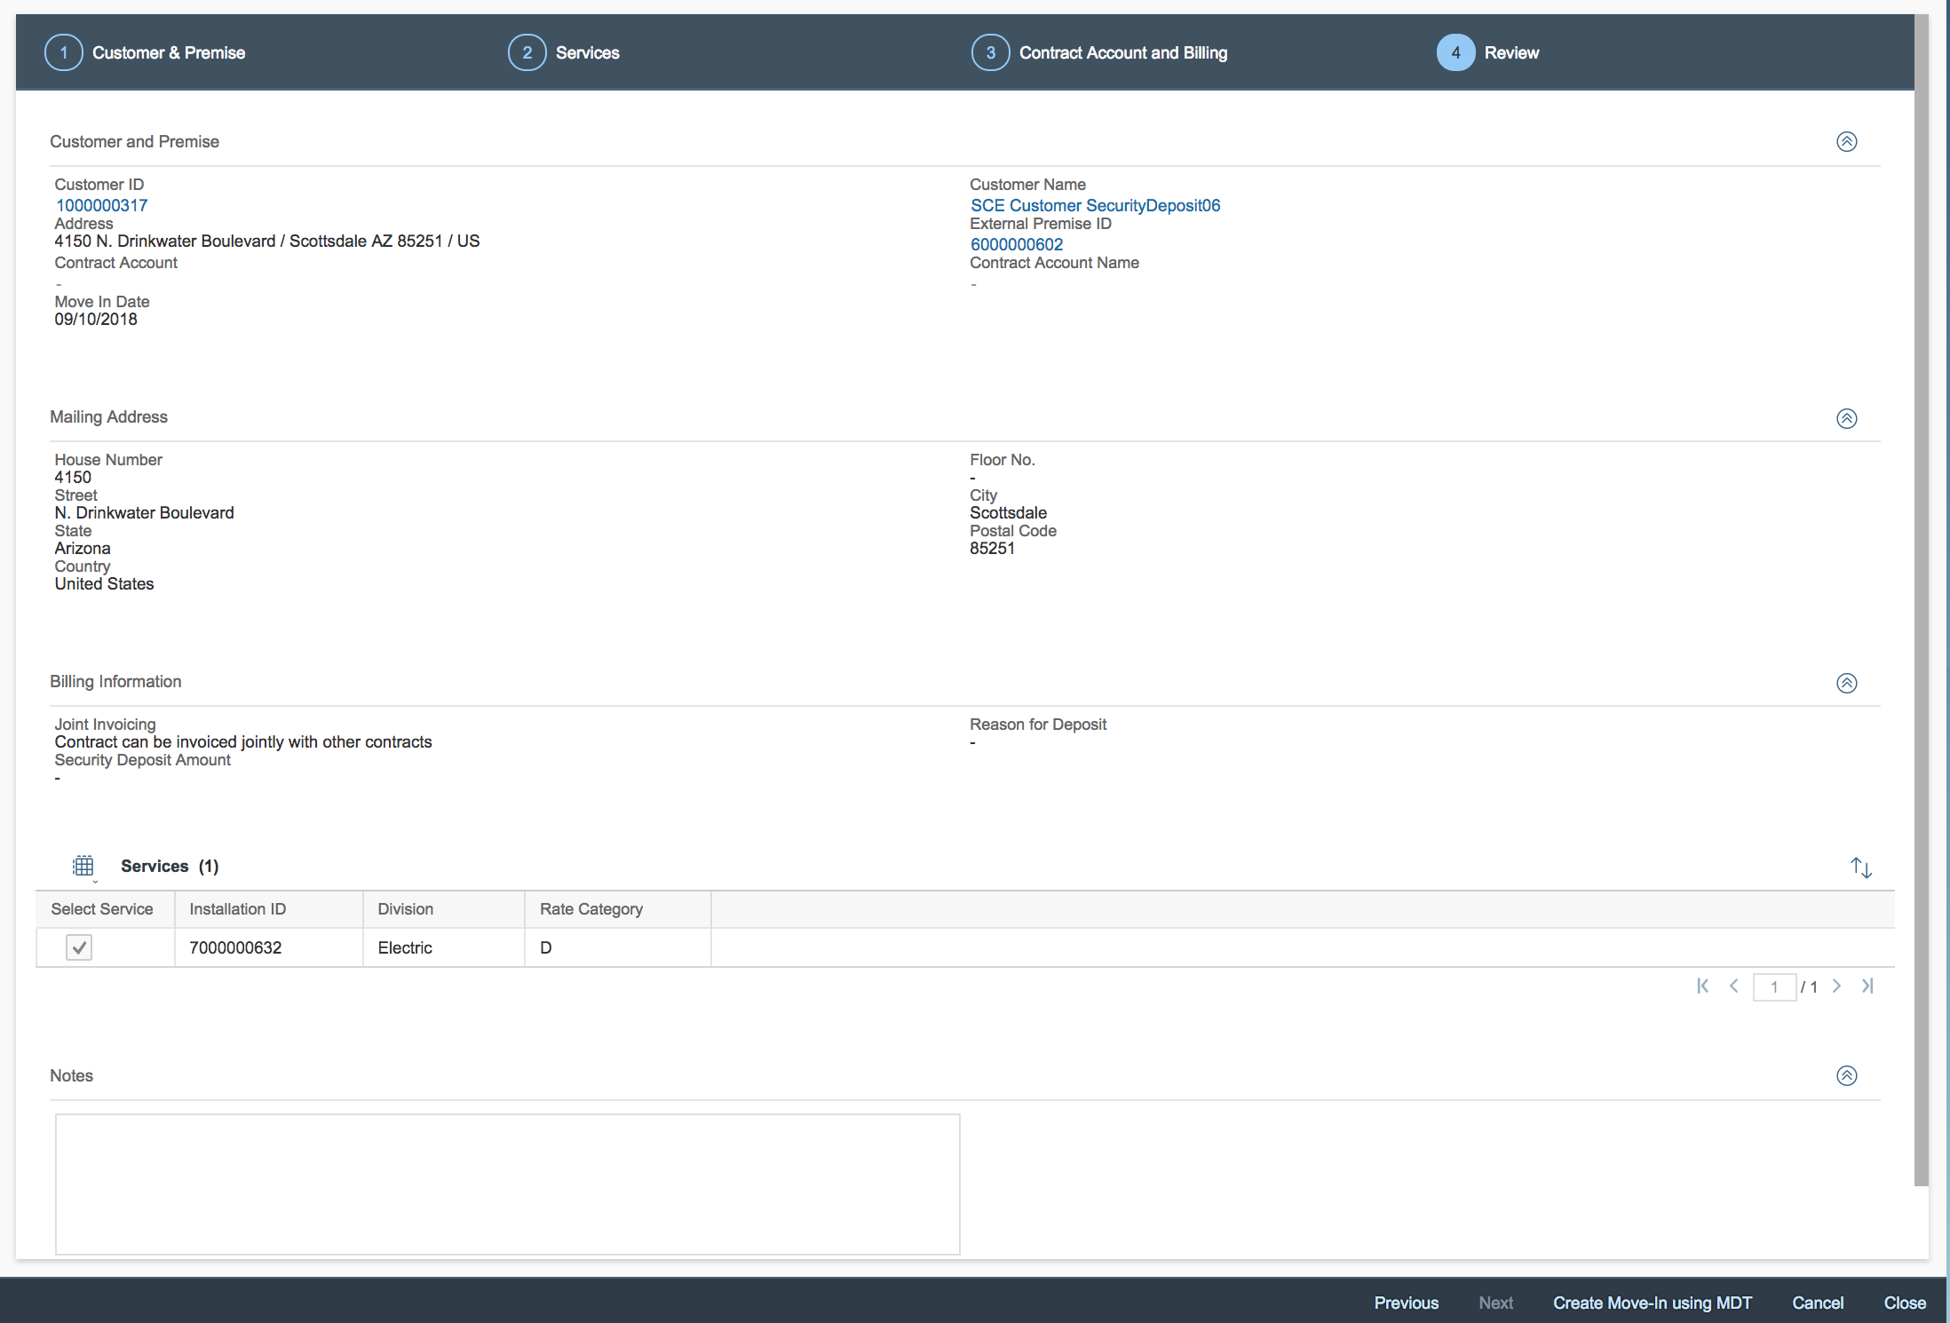
Create Move-Out
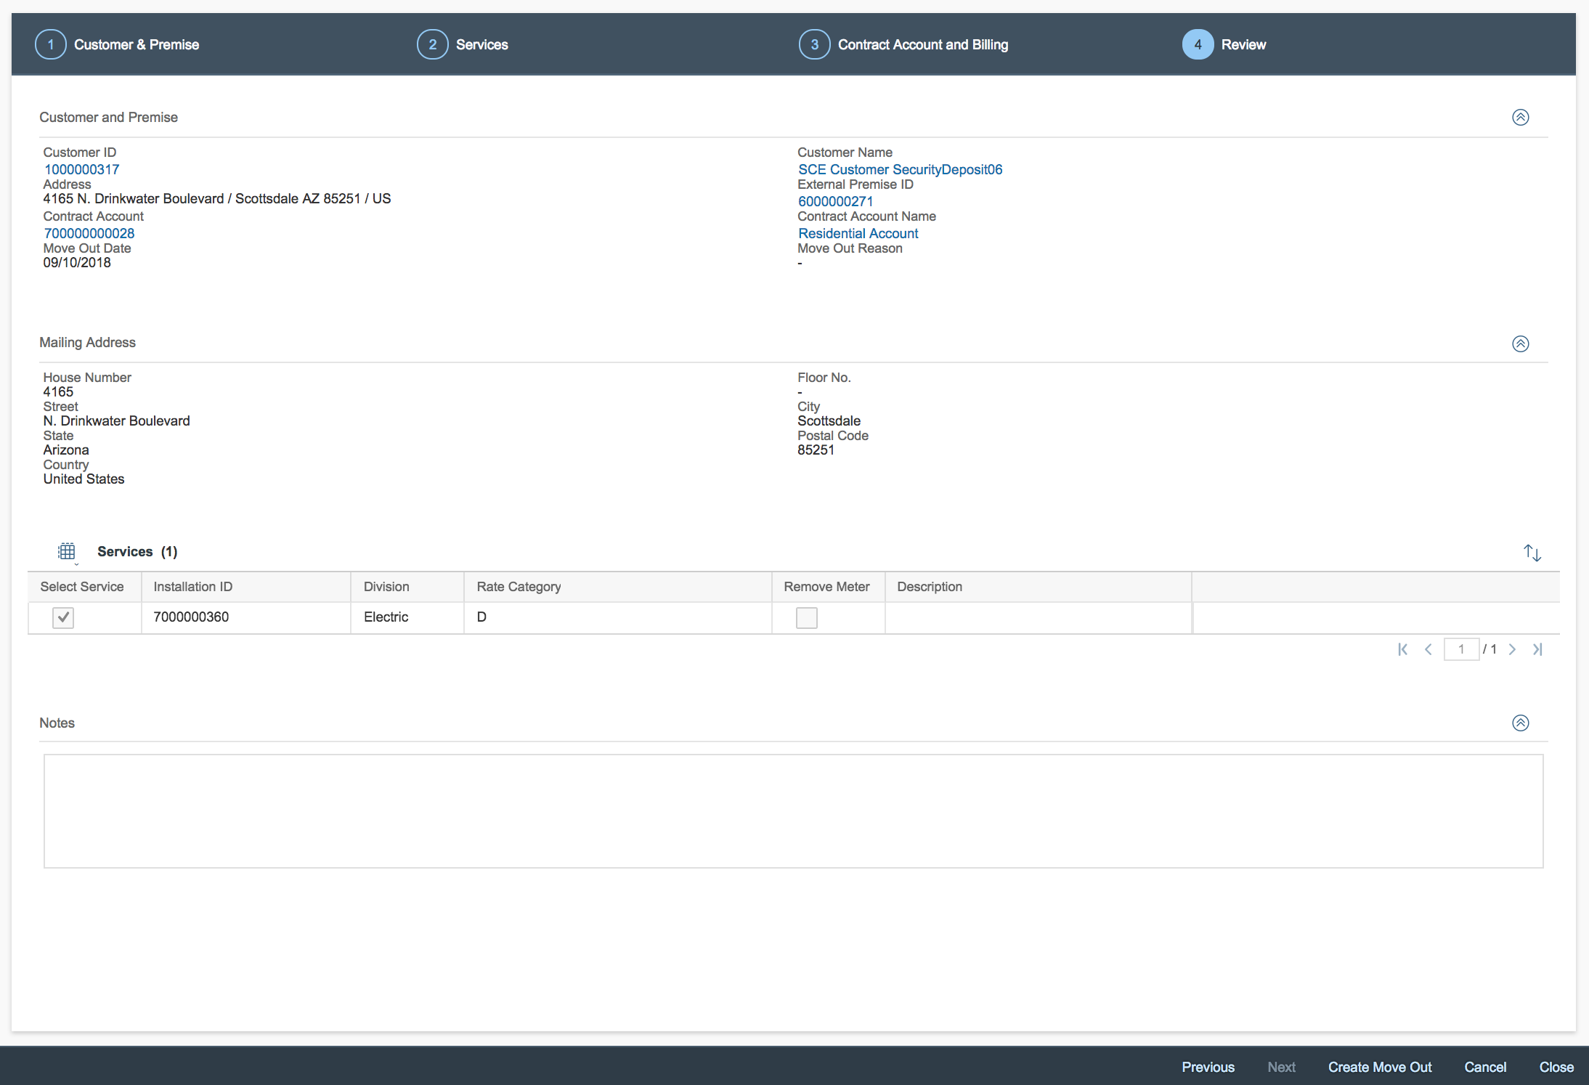

Create Transfer
(Note: When a transfer is submitted, while the UI is slightly different for the user, in S4/HANA it’s treated as a move-out and move-in.)
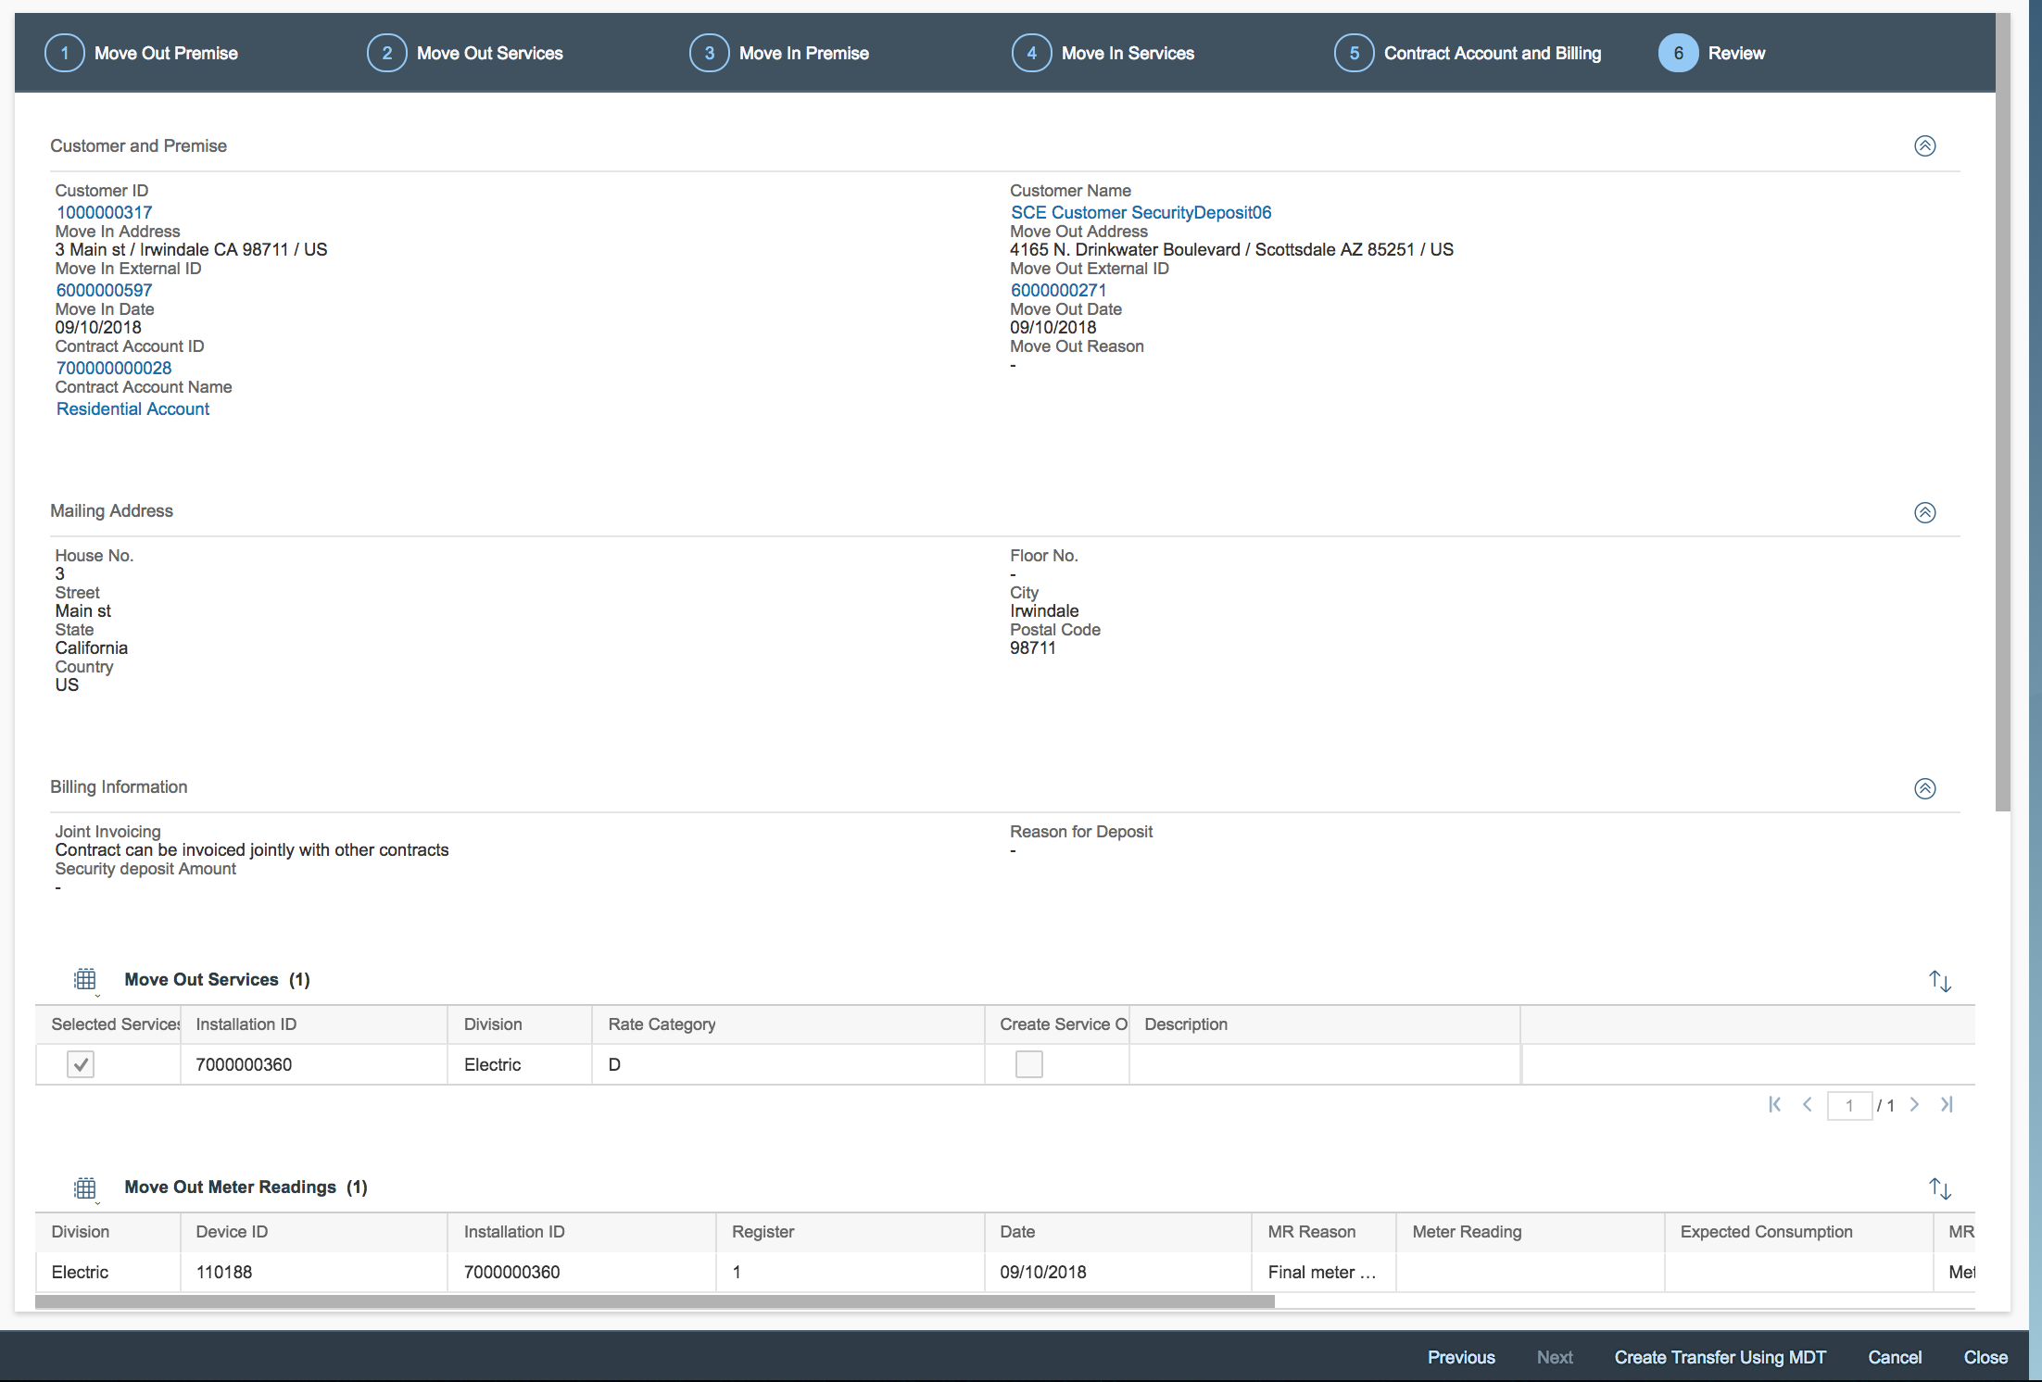
The overview of the process is detailed below. To illustrate the process flow, both move-in and move-out were consolidated into one process diagram.

Step | Description | Logic
000 | Start | Process begins.
010 | Move-in/Out is Created | The triggering event to this enhancement is the creation of the move-in/move-out within C4C.
020 | Move-In/Out Enhancement | - If a move-in is being performed, then the Enhancement on Move-In Creation will be invoked.  - If a move-out is being performed, then the Enhancement on Move-out creation will be invoked.
030 | BRF+ Validations | - If the triggering event is the creation of a move-in, then the Enhancement on Move-In creation will invoke the BRF+ function to perform the move-in validations. The BRF+ validation is triggered for each installation.  - If the triggering event is the creation of a move-out, then the Enhancement on Move-Out creation will invoke the BRF+ function to perform the move-Out validations. The BRF+ validation is triggered for each installation.  Output: Once the BRF+ validations are completed, the function will output back to the triggering enhancement a return structure which will contain the following fields, which are Boolean and will contain either TRUE or FALSE.  - Opt-In  - Opt-Out  - Meter Removal  - Disconnect/Reconnect  - Exit  Only one of the above return values will contain the value ‘TRUE’ which will drive the subsequent processing.
040 | Decision: Disconnect/Reconnect or Other? | In this step, the return from the BRF+ function will be evaluated.  - If ‘Opt-In’ or ‘Opt-Out’ or ‘Meter Removal’ is TRUE Goto step 060.  - If ‘’Disconnect/Reconnect’ = ‘TRUE’Goto step 050.  - If ‘Exit’ = ‘TRUE’ Goto END.  Note: ‘Exit’ will be returned when the move-in is for an installation with division ‘99’ (Added Facility), or in cases where the move-in has a billing block (which prevents the turn-on from being created).
050 | Generate Disconnect Reconnect. | The D&F enhancement 1467 E-DF-WM-03-Disconnection and Reconnection Document Order/Rules will be called, which will determine and generate the required turn-on/off service order or RSS.
060 | Create Other Service Order | In this step, the service order for opt-in or opt-out (meter exchange) and meter removal (dependent upon BRF+ output) will be created by the enhancement.
070 | Decision: Is the requested disconnect/reconnect a future dated RSS? | For future dated RSS (for AMI), the D&F enhancement will not generate RSS messages. On the date of the move-in/out, the Batch program for Move-in/out will be used to generate the required RSS.  If a future dated RSS is required goto step 080.  If a future dated RSS is not requiredgoto 085.
080 | Batch Process | The daily batch process will handle the move-in/out turn-on/off.
085 | Create Disconnect/Reconnect | The D&F enhancement 1467 E-DF-WM-03-Disconnection and Reconnection Document Order/Rules will create the required RSS or service order.
END | End | End of Process

SAP Transaction(s)
N/A

Input Data / Output Data
Refer to section 7.2.3

Business Logic
This functional specification includes the following enhancements:
- Enhancement on Move-Out Creation
- Enhancement on Move-In Creation
- Batch Program for Move-Out Processing*
- Batch Program for Move-In Processing*
*Note: The batch program will be 1 program with two processing modes, but to simplify the documentation of the enhancement, the logic for each processing mode will be detailed separately.
Enhancement on Move-Out Creation
This enhancement should be built as a single function module. By having this built as a single function module, it can be reused by both SCE.COM and IDEX. The custom function module should be implemented within the following enhancement spot:
Enhancement Spot: COD_UTILITIES_ERP_CUST_INFO
Function Module: ISU_C4C_MOVE_IN_OUT_TRANS_SRV
Method: MOVE_IN_OUT_TRA_POST

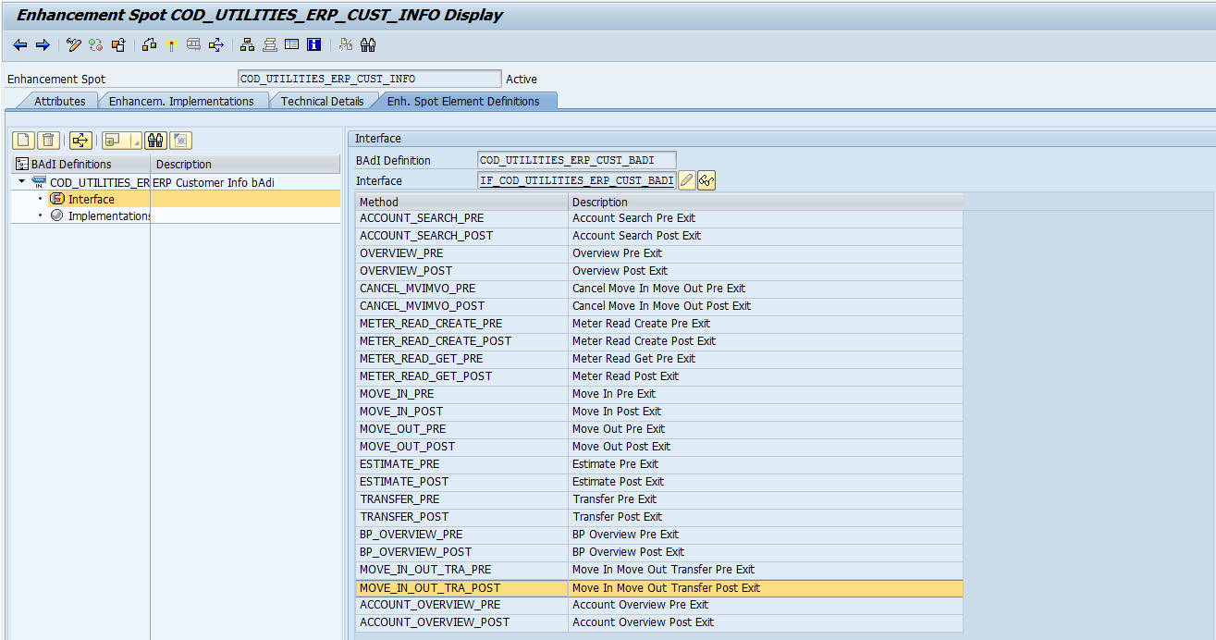
This custom function module will process each entry passed within the T_CONTRACTDATA_MOVEOUT table. The table may contain more than one installation, as SCE can have multiple installations on the same premise. For each row within the table, the function module will first call a BRF+ function that will perform multiple checks to determine if a service order or RSS needs to be generated to the field. Once the result is received from BRF+, then the required service order or RSS will be generated.
*Note: RSS are only generated through this enhancement for same day or backdated move-outs. Future move-out RSS are generated through the batch process detailed later in this document.
The BRF+ function to be called is displayed below:
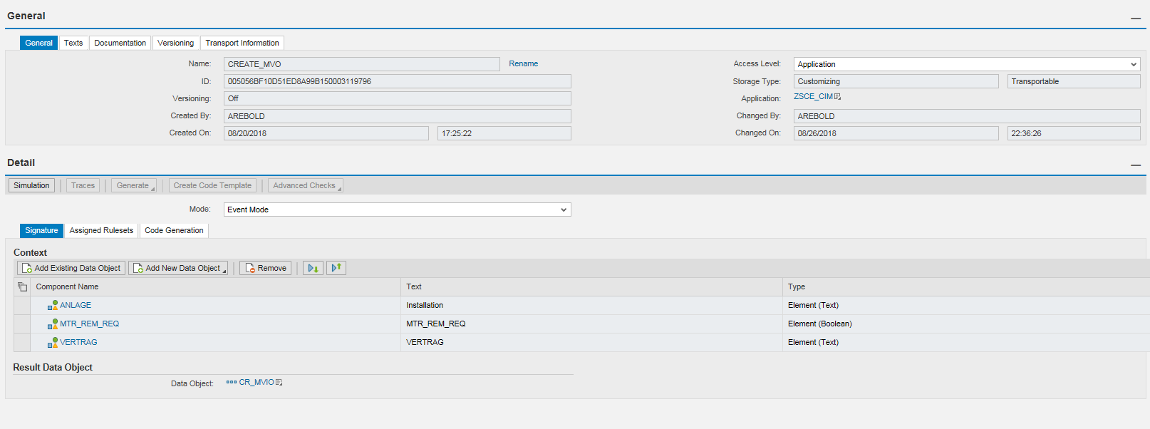
The inputs that the FM should pass into the BRF+ function are listed below:
Parameter | Type | Description
ANLAGE | EANL-ANLAGE | Installation Number  From the parameter T_CONTRACTDATA_MOVEOUT-INSTALLATION
MTR_REM_REQ | BOOLEAN | TRUE or FALSE  From the parameter T_CONTRACTDATA_MOVEOUT- CREATE_SERVICE.  If CREATE_SERVICE = ‘X’, then TRUE should be passed to the BRF+ function.  If CREATE_SERVICE = SPACE, then FALSE should be passed to the BRF+ function.
VERTRAG | EVER-VERTRAG | Contract Number  From the parameter T_CONTRACTDATA_MOVEOUT-CONTRACT.

The output of the BRF+ function will be the following structure:
Parameter | Type | Description
OPT_IN_SO | BOOLEAN | TRUE or FALSE will be returned by BRF+.  If TRUE, then a meter exchange for opt-in will be returned.
DISC_RECN | BOOLEAN | TRUE or FALSE will be returned by BRF+.  If TRUE, then a disconnection/reconnection should be issued.
OPT_OUT_SO | BOOLEAN | TRUE or FALSE will be returned by BRF+.  If TRUE then an Opt-Out Meter Exchange service order should be created.
MTR_REMOVAL | BOOLEAN | TRUE or FALSE will be returned by BRF+.  If TRUE then a meter removal service order should be created.
EXIT | BOOLEAN | TRUE or FALSE will be returned by BRF+.  If TRUE, then no further processing is required.
*Note: the return structure above is used for both move-in and move-out BRF+. It is assumed that only 1 of the outputs will return with ‘TRUE
After the BRF+ function has completed processing, the custom function module will check which of the above outputs returned with TRUE, which will determine what (if any) additional processing is required. The additional process is detailed below:

Step | Description | Logic
000 | Start | Enhancement is triggered
010 | Decision: Is the installation division = ‘99’ (Added Facility)? | This validation will check if the installation is division ‘99’ for added facilities. Added facilities do not require a service order or RSS, and therefore, would skip this logic.  If the installation is added facilitiesGoto END.  If the installation division is NOT added facilityProceed to step 020.
020 | Decision: Is the customer requesting a meter removal? | If the customer is requesting a meter removal, C4C will pass ‘X’ within the following parameter T_CONTRACTDATA_MOVEOUT- CREATE_SERVICE for the installation.  This indicates that the customer requested a meter removal.
030 | Create meter removal service order. | The BRF+ function will output ‘TRUE’ for parameter MTR_REMOVAL. The enhancement will read the ‘TRUE’ for the ‘MTR_REMOVAL’ parameter and should create the meter removal service order using FM ISU_C4C_SRV_ORD_CREATE, exporting:  IV_ACTIONCODE = ‘01’  IS_HEADER-ORDER_CODE = Z214  IS_HEADER-START_DATE = Move-Out Requested Date. (If the Move-Out requested date is in the past, the service order will be issued for system date)  IS_HEADER-CUSTOMER = <BP Number>  IS_HEADER-OBJECTTYPE = ‘02’  IS_HEADER-REF_OBJECT=<equipment number>
040 | Decision: is the installation in Catalina? | This validation is to check if the installation is in Catalina. Catalina installations are not AMI, and are not eligible for opt-out/opt-in, which is why this check is performed.  To determine if an installation is in Catalina, the BRF+ function will check if EANL-ABLESARTST = ‘CATLINA’.  If the installation is in Catalina, goto step050  If the installation is not in Catalina, goto step 060.
050 | Disconnection service order is created. | The BRF+ function will return with DISC_RECN = ‘TRUE’. The enhancement will then call the D&F enhancement that will check the meter status and create the required service order for the disconnection. (Catalina requires service orders as all meters are mechanical).  1467 E-DF-WM-03-Disconnection and Reconnection Document Order/Rules  The following parameters will be passed:  Installation #  Date (same as input date)  Activity (Move-Out)
060 | Decision: Is there a next-day move-in? | This validation is to check if there’s a move-in the next day. If a next day move-in exists, then the installation should not be disconnected.  The BRF+ function will check if an entry exists in EVER where Move-In date = Move-out Date + 1 day AND ANLAGE = <installation number> and LOEVM = SPACE (not cancelled).  If a next day move-in exists, then EXIT output is updated to ‘TRUE’ to end processing.  If a next day move-in does not exist goto step 070.
070 | Decision: Is the meter installed AMI | This step requires the custom function module (to determine if the device is AMI) to be invoked within BRF+ using the procedure call.  If the function module returns ‘X’ (meter is AMI), goto step 090.  If the function module returns SPACE (meter is not AMI), goto step 080.
080 | Create Opt-In Service Order | The BRF+ function will return ‘TRUE’ in OPT_IN_SO. The enhancement will be required to derive the installed meter at the installation and create a service order type Turn-Off Opt-In to exchange the meter to AMI.  Using the installation number, derive the logical device numbers from table EASTL. Input the installation number (input parameter) into EASTL-ANLAGE, and get all values from LOGIKNR where BIS = 12/31/9999 and AB >= sys-datum. More than 1 LOGIKNR may be returned if multiple devices are installed.  Input the LOGIKNR into EGERH-LOGIKNR and get all values from EQUNR where BIS = 12/31/9999 and AB >= sy-datum and KOMBINAT = ‘Z’. Sort the list by DEVLOC and remove duplicates (so that only 1 service order is created per device location).  Create 1 service order for each unique equipment number/device location using FM ISU_C4C_SRV_ORD_CREATE; exporting  IV_ACTIONCODE = ‘01’  IS_HEADER-ORDER_CODE = ‘Z233’  IS_HEADER-START_DATE = Move-Out Requested Date.  IS_HEADER-CUSTOMER = BP Number  IS_HEADER-OBJECTTYPE = ‘02’  IS_HEADER-REF_OBJECT=EQUNR  If the Move-Out date is in the past, the service order is issued for system date.
090 | Disconnection service order/RSS is created. | The BRF+ function will return DISC_RECN = ‘TRUE’. The enhancement will then call the D&F enhancement which will check the meter status and create the required service order for the disconnection  Note: If the move-out is for a future date, and the meter is AMI, the enhancement below will NOT create the RSS. Future dated RSS are generated on the date of the move-in/out through the batch process detailed later in this document.  1467 E-DF-WM-03-Disconnection and Reconnection Document Order/Rules  The following parameters will be passed:  Installation #  Date (same as input date)  Activity (Move-Out)
END | End | End of processing

Enhancement on Move-In Creation
This enhancement should be built as a single custom function module so that it can be reused for SCE.COM and IDEX. This custom function module should be added within the function module ISU_C4C_UTILITIES_MDT_MVI_CRT as an implicit enhancement. As a part of 1090 E-CIM-CS-02 - Capture Opt Out, Inspection Required and service fees, multiple custom attributes are being passed within the X_CONTAINER which are required for this enhancement, and therefore, this must be implemented as an implicit enhancement so that those contents may be read.
This enhancement should only be triggered when the X_MDT_PROCESS_CODE = ‘0003’ (move-in). Within the custom function module, a BRF+ function will be called which will perform multiple checks to determine if a service order or RSS needs to be generated to the field to issue the reconnection.
The BRF+ function will be called for each installation (contract). Once the result is received from BRF+, then the required service order or RSS will be generated (if needed/applicable).
The BRF+ function to be called is displayed below:
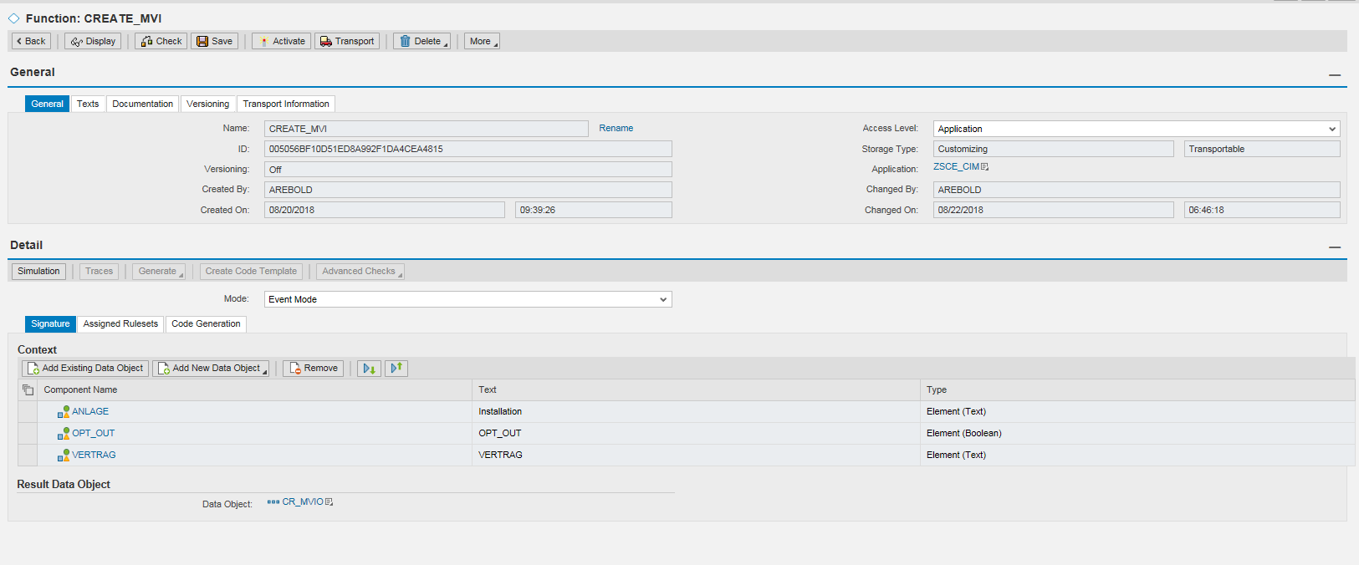
The inputs to the BRF+ function are listed below.
*Note: RSS to AMI meters are only generated for same day or backdated move-outs. Future move-out RSS are issued through the batch process.

Parameter | Type | Description
ANLAGE | EANL-ANLAGE | Installation Number  From XY_NEW_KEYS_TAB where NAME = ANLAGE
OPT_OUT | BOOLEAN | TRUE or FALSE. Will be provided from C4C within the X_CONTAINER. (1090 E-CIM-CS-02 - Capture Opt Out, Inspection Required and service fees)
VERTRAG | EVER-VERTRAG | Contract Number  From XY_NEW_KEYS_TAB where NAME = VERTRAG

The outputs of the BRF+ function are the following:
Parameter | Type | Description
OPT_IN_SO | BOOLEAN | TRUE or FALSE will be returned by BRF+. If TRUE, then a meter exchange for opt-in will be returned.
DISC_RECN | BOOLEAN | TRUE or FALSE will be returned by BRF+. If TRUE, then a disconnection/reconnection should be issued.
OPT_OUT_SO | BOOLEAN | TRUE or FALSE will be returned by BRF+. If TRUE, then an Opt-Out Meter Exchange service order should be created.
EXIT | BOOLEAN | TRUE or FALSE will be returned by BRF+. If TRUE, then no further processing is required.
*Note: the return structure above is used for both the move-in and move-out BRF+ function. It is assumed that only 1 of the above output parameters will return with ‘TRUE’.
After the BRF+ function has completed processing, the enhancement will check which of the above outputs returned with ‘TRUE’, which will determine what (if any) additional processing is required. The additional processing is detailed in the diagram below.
Step | Description | Logic
000 | Start | Enhancement is triggered.
010 | Decision: Does this move-in have a billing block? | - If the contract has a billing blockgoto end. The BRF+ will return EXIT = ‘TRUE’.  - If the contract does not have a billing blockproceed to step 020.
020 | Decision: Is the installation division = ‘99’ (Added Facility)? | This validation will check if the installation is division ‘99’ for Added facility.  - If the division is added facilitygoto END.  - If the division is not added facilitygoto step 030.
030 | Decision: Is the installation in Catalina? | This validation is to check if the installation is in Catalina. Catalina installations are not AMI, and are not eligible for opt-out/opt-in, which is why this check is performed.  To determine if an installation is in Catalina, the BRF+ function will check if EANL-ABLESARTST = ‘CATLINA’.  If the installation is in Catalina, goto step040  If the installation is not in Catalina, goto step 050.
040 | Reconnection service order is created. | The BRF+ function will return with DISC_RECN = ‘TRUE’. The function module will then call the D&F enhancement that will check the meter status and create the required service order for the reconnection (Catalina requires service orders as all meters are mechanical).  1467 E-DF-WM-03-Disconnection and Reconnection Document Order/Rules  The following parameters will be passed:  Safety Message (Y or N)  Installation #  Date (same as input date)  Activity (Move-In)
050 | Decision: Did the customer request to Opt-Out? | This step is to check the input parameter OPT_OUT_REQ, which would indicate if the move-in customer requested to opt-out of the AMI program. This is a custom field which will be passed from C4C to S4 and into this BRF+ function (1090 E-CIM-CS-02 - Capture Opt Out, Inspection Required and service fees)  If the customer requested to Opt-Out = ‘X’ goto step 055.  If the customer did not request to Opt-Outgoto step 070.
55 | Decision: Is there an outstanding Move-Out (Turn-Off) Opt-In Service Order? | The BRF+ function returned Opt-Out = X. Now the function module will need to determine check for an outstanding Turn-off Opt-In Service Order which will replace the mechanical meter with AMI. Since the customer is requesting a mechanical meter, by checking for an AMI opt-in order, we are trying to prevent field from changing the meter from mechanical AMImechanical.  To find open orders, the standard Class: CL_COD_UTIL_SRV_ORD_HELP  Method: GET_SERVICE_ORDERS can be leveraged. The return et_service_orders, returns all service orders. Therefore, from the return table, the function should check for the following:  SERVICE_ORDER_TYPE: TOFF  STATUS =only ‘10’ and ‘20’ are permitted.  If service orders are found –then you will get the service order numbers and pass into table AFIH-AUFNR. If any of the service orders have AFIH-ILART = ‘233’ – this indicates that an open Turn-off Opt-In exists. Proceed to step 060.  If an open Turn-off Opt-In is found goto step 065  If an open Turn-Off Opt-In is NOT found goto step 060
060 | Create Turn-On with Opt-Out to replace the meter to mechanical. | The BRF+ function returns ‘TRUE’ in OPT_OUT_SO. The function module will create a service order Turn-On Opt-Out to exchange the meter to mechanical.  Using the installation number, derive the logical device numbers from table EASTL. Input the installation number (input parameter) into EASTL-ANLAGE, and get all values from LOGIKNR where BIS = 12/31/9999 and AB >= sys-datum. More than 1 LOGIKNR may be returned if multiple devices are installed.  Input the LOGIKNR into EGERH-LOGIKNR and get all values from EQUNR where BIS = 12/31/9999 and AB >= sy-datum and KOMBINAT = ‘Z’. Sort the list by DEVLOC and remove duplicates (so that only 1 service order is created per device location).  Create 1 service order for each unique equipment number/device location using FM ISU_C4C_SRV_ORD_CREATE; exporting  IV_ACTIONCODE = ‘01’  IS_HEADER-ORDER_CODE = ‘Z237’  IS_HEADER-START_DATE = Move-In Requested Date.  IS_HEADER-CUSTOMER = BP Number  IS_HEADER-OBJECTTYPE = ‘02’  IS_HEADER-REF_OBJECT=EQUNR  If the Move-In date is in the past, the service order is issued for system date.
65 | Cancel Open Turn-off Opt-In | In this scenario, the premise already has a mechanical meter, and an inflight meter exchange (to change the meter to AMI) exists. To prevent the field from having to change the meter from mechanical AMImechanical, then outstanding service order (to change from mechanical to AMI) is cancelled. This will allow the mechanical meter to remain in place, since the customer moving in is requesting to opt-out.  The cancel the service order, the following can be used:  CALL FUNCTION ISU_C4C_SRV_ORD_CREATE  IMPORTING  IV_ACTIONCODE = ‘03’  IS_HEADER-CUSTOMER = <BP Number>  IS_NUMBER = <service order number>
070 | Decision: Is the meter installed AMI? | This step requires the custom function module to be invoked within BRF+ using the procedure call to determine if the meter is AMI.  If the function module returns ‘TRUE’ (meter is AMI), goto step 090.  If the function module returns FALSE (meter is not AMI), goto step 080.
075 | Decision: Is there an outstanding Move-Out (Turn-Off) Opt-In Service Order? | The BRF+ function returned Opt-In = X. Now the function module will need to cehck for an outstanding Turn-off Opt-In Service Order which will replace the mechanical meter with AMI. Since the customer is not opt-ing out, by checking for an Turn-Off Opt-In Order, we are trying to prevent having two open opt-in orders.  To find open orders, the standard Class: CL_COD_UTIL_SRV_ORD_HELP  Method: GET_SERVICE_ORDERS can be leveraged. The return et_service_orders, returns all service orders. Therefore, from the return table, the function should check for the following:  SERVICE_ORDER_TYPE: TOFF  STATUS =only ‘10’ and ‘20’ are permitted.  If service orders are found –then you will get the service order numbers and pass into table AFIH-AUFNR. If any of the service orders have AFIH-ILART = ‘233’ – this indicates that an open Turn-off Opt-In exists. Proceed to step 060.  If an open Turn-off Opt-In is found goto END  If an open Turn-Off Opt-In is NOT found goto step 080
080 | Create Turn-On with Opt-In service order | The BRF+ function will return OPT_IN_SO = TRUE. The enhancement will create a service order Turn-On Opt-In to exchange the meter to mechanical.  Using the installation number, derive the logical device numbers from table EASTL. Input the installation number (input parameter) into EASTL-ANLAGE, and get all values from LOGIKNR where BIS = 12/31/9999 and AB >= sys-datum. More than 1 LOGIKNR may be returned if multiple devices are installed.  Input the LOGIKNR into EGERH-LOGIKNR and get all values from EQUNR where BIS = 12/31/9999 and AB >= sy-datum and KOMBINAT = ‘Z’. Sort the list by DEVLOC and remove duplicates (so that only 1 service order is created per device location).  Create 1 service order for each unique equipment number/device location using FM ISU_C4C_SRV_ORD_CREATE; exporting  IV_ACTIONCODE = ‘01’  IS_HEADER-ORDER_CODE = ‘Z236’  IS_HEADER-START_DATE = Move-In Requested Date.  IS_HEADER-CUSTOMER = BP Number  IS_HEADER-OBJECTTYPE = ‘01’  IS_HEADER-REF_OBJECT=<Premise #>  If the Move-In date is in the past, the service order is issued for system date.
090 | Reconnection service order is created. | The BRF+ function will return with DISC_RECN = TRUE. The enhancement will then call the D&F enhancement 1467 E-DF-WM-03-Disconnection and Reconnection Document Order/Rules that will check the meter status and create the required service order or RSS for the reconnection.  Note: If the move-in is for a future date, and the meter is AMI, the enhancement below will NOT create the RSS. Future dated RSS are generated on the date of the move-in/out.  The following parameters will be passed:  Safety Message (Y or N) (From the X_CONTAINER, being passed from 1090 E-CIM-CS-02 - Capture Opt Out, Inspection Required and service fees)  Installation #  Date (same as input date)  Activity (Move-In)
END | End | End of processing

Batch Program for Move-in/Out
A batch program to process move-in turn-ons and move-out turn-offs will be built in S4/HANA. This batch program will process all move-in and move-out documents that are due to occur on system date, and determine if an RSS (turn-on/off) is required. One program will be used to handle both move-in and move-out that will be controlled by a radio button on the selection screen. The input parameters are as follows:

Parameter | Type | Description
Move-In | Checkbox (CHAR1) | Input parameter: The user can only select either Move-In or Move-Out processing mode. Both cannot be selected. Validation is required to ensure the user does not select both.
Move-Out | Checkbox (CHAR1) | Input parameter: The user can only select either Move-In or Move-Out processing mode. Both cannot be selected. Validation is required to ensure the user does not select both.
Date | DATS(8) | Input Date Field.

During processing, the results of the batch program will be written to the application log for future reference by IT (refer to the application log batch job steps below).

Move-Out Batch Process
This processing mode of the batch program derive all of the move-out documents from EAUSV based on the input parameter move-out date. Then, each move-out document will be passed into the BRF+ function individually. The input into the BRF+ function will be fields from the EAUSV table:
Parameter | Type | Description
AUSZBELEG | EAUSV-AUSZBELEG | Move-Out Document Number
ANLAGE | EAUSV-ANLAGE | Installation number
VERTRAG | EAUSV-VERTRAG | Contract Number
AUSZDAT | EAUSV-AUSZDAT | Move-Out Date
VSTELLE | EAUSV-VSTELLE | Premise number

The output of the BRF+ will provide the text, which should be written to the application log for each processed move-out document. Additionally, if an RSS needs to be generated, this will be returned in the field RSS, which will be either ‘TRUE’ or ‘FALSE’
Parameter | Type | Description
RSS | BOOLEAN | TRUE or FALSE  - If an RSS needs to be generated, this will return TRUE.  - If an RSS is not needed, or any of the validations fail, FALSE will be returned.
MESSAGE | CHAR(40) | Text to be written to application log.

Step | Description | Logic
000 | Start | The batch program for move-out disconnections is initiated. This program will run daily between 1-5 AM (exact time TBD). This program should be executed prior to the Batch Program for Move-In.
010 | The first step in the batch program is to derive all move-out documents that are due to occur on date defined (system-date). | Identify Move-out on system date of Batch Run:  Check table EAUSV for current move-outs  - System-date = AUSZDAT  - Program should remove move-outs that have been reversed, where STORAUSZ = X
020 | The batch program will process each move-out document through the BRF+ checks. | None.
030 | Check 1: This check is to determine if a next day move-in exists. | The BRF+ function will check for a next day move-in.  - If a next day move-in is found, the BRF+ function will return ‘Next Day Move-In” and the batch process should write ‘Next Day Move-In for <move-out doc #>’ in the application log.  - If a next day move-in is not found, then proceed to the next check in step 040.
040 | Check 2: This check is to determine if an active owner allocation agreement exists. | The BRF+ function will check for an active owner allocation (table EPROP)  - If an active owner allocation agreement exists, then the function will return ‘Owner Allocation’ within the MESSAGE text. ‘Owner Allocation’ + <move-out document number> should be written in the application log. Proceed to step 080.  - If an owner allocation agreement does not exist, then proceed to the next check in step 050.
050 | Check 3: This step is to determine if a meter turn-off or meter replacement service order already exists. | To find existing service orders, a custom method will be used, which is included in W-CIM-CS-02 Align new Move-In Date with Service Order.  - If an open service order is found, goto step 080 and write ‘Open Service Orders for <move-out doc#>’ in the application log.  - If open service orders are not found, goto step 060.
060 | Check 4: This check is to determine if the location is already disconnected. | To determine if the location is currently disconnected, the following FM will be used by the BRF+ function:  CALL FUNCTION ISU_INSTLN_STATUS_DETERMINE  EXPORTING  X_ANLAGE = <installation #>  X_KEYDATE = <system date>  IMPORTING  Y_EANLDISCST = lv_status  - If lv_status =’05’ or ‘10’, then it’s already disconnectedgoto step 080, where the message ‘Installation disconnected for move-out doc <move-out doc number>’.  - If lv_status = ‘00’ or ‘15’ or then the installation needs to be disconnected goto step 070.
070 | The disconnection is required. The D&F enhancement is called to generate the RSS. | This enhancement, which will create the disconnection RSS, will be developed in 1467 E-DF-WM-03-Disconnection and Reconnection Document Order/Rules  The following parameters will be passed:  Installation #  Date (same as input date)  Activity (Move-Out)  The required RSS message will be generated through the D&F enhancement. The message to the application log will be ‘Disconnection RSS generated for <move-out doc #>’.
080 | Application log is updated | Application Log Details  Object: ZCIM  SubObject: ZMVO_BATCH  Subobject Text: Move-Out Batch Processing  Message: Depends on the failed condition (text defined in the failed step).
090 | Are there additional move-out documents, which require processing? | The batch program will check if additional move-out documents require processing, and will commence the checks for any remaining documents.
END | End | End of batch processing

Move-In Batch Process
This processing mode of the batch program will first derive all of the move-in documents from EEINV based on the input parameter move-in date. Then, the batch program should pass each move-in document into the BRF+ function. The input into the BRF+ will be fields from the EEINV table:

Parameter | Type | Description
EINZBELEG | EEINV- EINZBELEG | Move-In Document Number
ANLAGE | EEINV -ANLAGE | Installation number
VERTRAG | EEINV -VERTRAG | Contract Number
AUSZDAT | EEINV -AUSZDAT | Move-Out Date
VSTELLE | EEINV -VSTELLE | Premise number

On completion of the BRF+ function, the return will contain the text to be passed to the application log.
Parameter | Type | Description
RSS | BOOLEAN | TRUE or FALSE  - If an RSS needs to be generated, this will return TRUE.  - If an RSS is not needed, or any of the validations fail, FALSE will be returned.
MESSAGE | CHAR(40) | Text to be written to the application log.

Step | Description | Logic
000 | Start | The batch program is initiated.
010 | The first step in the batch program is to derive all move-in documents that are due to occur on date defined (system-date). | This program will run daily between 1-5 AM (exact time will be determined during batch scheduling).  Derive all move-ins that are due for the input date by reading table EEINV for current move-ins  - EINZDAT = Input date (system-date)  - Program should remove move-ins that have been reversed, where STORKONZ = ‘X’
020 | The batch program will process each move-in document and perform each of the subsequent checks. | The BRF+ function for move-in validations will be called.
030 | Check 1: This check will determine if the contract has a Billing Block. A billing block will be set for a variety of factors, including Fuse Up Inspection and Same Party Indicator. If the Billing block is set on the contract, the turn-on will not be processed. | To determine if a billing block was set, the BRF+ function will check EVER-ABRSPERR.  - If EVER-ABRSPERR NE SPACE, then a billing block exists. Goto step 080. BRF+ function will return “Billing Block”. The batch process should write ‘Billing Block’ + <move-in doc #>” to the application log.  - If EVER-ABRSPERR EQ SPACE, then a billing block has not been setGoto step 040.
040 | CHECK 2: This check is to determine if the location has power flow. The batch program should not create a reconnection order if the location is already on. | To determine if the location is currently connected (energized) the following FM will be used by the BRF+ function:  CALL FUNCTION ISU_INSTLN_STATUS_DETERMINE  EXPORTING  X_ANLAGE = <installation #>  X_KEYDATE = <system date>  IMPORTING  Y_EANLDISCST = lv_status  - If lv_status = ‘05’ or ‘10’, then a reconnection is required Goto step 050.  - If lv_status NE ‘050 or ‘10’, then a reconnection will not be created Goto step 070, where the message ‘Reconnection not needed for move-in doc <move-in doc number>’.
050 | Check 3: This check is to determine if a Replacement TUON or TUON SO already exists. | In this check, the system will determine if an open turn-on service order (to energize or replace the meter) already exists. These are created as a result of the following:  - The meter is not RSS enabled for connection  - The customer requested to opt-out of the AMI program (Turn-on w/ meter replacement)  - The customer did not accept the safety message. If a service order already exists, then an RSS is not needed.  To find existing service orders, a custom method will be used, which is included in W-CIM-CS-02 Align new Move-In Date with Service Order.  - If an open service order is foundgoto step 070 where the message ‘Open Service Orders for <move-in doc#>’ will be written in the application log.  - If open service orders are not found goto step 060.
060 | A reconnection is required. The D&F enhancement is called to generate the RSS. | This enhancement, which will create the reconnection RSS, will be developed in 1467 E-DF-WM-03-Disconnection and Reconnection Document Order/Rules  The following parameters will be passed:  Installation #  Date (same as input date)  Activity (Move-In)  The required RSS message will be generated through the D&F enhancement. The message to the application log will be ‘Reconnection RSS generated for <move-in doc #>’.
070 | Application log is updated | The application log is updated.  Object: ZCIM  SubObject: ZMVI_BATCH  Subobject Text: Move-In Batch Processing  Message: Depends on the condition (will be defined in the batch step).  The logic for each processing mode is described below in the diagrams, and is detailed separately.
080 | Are there additional move-in documents, which require processing? | The batch program will check if additional move-in documents require processing, and will commence the checks for any remaining documents.
END | End | End of batch processing

User Exits
User Exit | Comments
N/A

Error Handling
Errors are written to the application log.

BADI – BP Contacts

Business Object

Input / Output Parameters
N/A

Business Logic
See section 7.2.3

Error Handling
N/A

Data Dictionary Object

Custom Table

Table Type
N/A

Number of Records
N/A

Field List
Seq | Field Name | Key Field? | Field Type | Field Length | Comments
1 | N/A

Table Maintenance
N/A

Search helps

Data Source
N/A

Search Fields
N/A

Output and Selectable Fields
N/A

Dialog program / Web Developments (BSP / Web Dynpro) / Web IC / C4C Views / C4C Flows

Screen Field and Layout Details
N/A

Screen Sequence
N/A

Business Logic
N/A

Custom Tables Updated
N/A

Error Handling
N/A

Multi-User Access Consideration
N/A

Branding Requirements
N/A

7.5.8 Security
Is a Custom Program for Production access required?
Custom Programs require an Authorization Group to be assigned. A Custom Transaction will be needed to execute the program. (Note: Production Access to SE38/SA38 is on exception basis only)
Is a Custom Table for Production access / maintenance required?
Custom Tables require an Authorization Group to be assigned. A Custom Transaction will be needed to access the table. (Note: Production Access to SE16/SM30 is on exception basis only)
Does the Custom Table have field(s) / enhancements that may require additional security?

Is a Custom Authorization Object required? Standard authorization object shall be leveraged before creating custom authorization object
Will a custom or standard InfoType/Subtype be created, changed or leveraged as part of the solution?

ABAP Programs shall include additional security authorization checks where applicable and technically feasible

Scope of the Development – Workflow

Workflow Development

Configuration
N/A

Triggering Mechanism
N/A

Creation/Change of Workflow
N/A

Workflow Business Logic
N/A

Action Agents / Responsible Person Determination Logic
N/A

Error Handling
N/A

Unit Test

Triggers
Creation of a move-in/out in C4C. Batch programs are triggered ad-hoc.

Test pre-conditions
N/A

Test Data
Contract Account 700000000824, installation 7000000349
Contract Account 700000000021, installation, 7000001007
Contract Account 200000000021, installation, 7000000517
Contract Account 700000000155, installation, 7000000518

Unit Test Specification

Test Case Description: Enhancement on Move-In Creation |  |  |  | Flagged for Technical Unit Test (Y/N)
# | Scenario Description | Expected Results | Comments
1 | Create a move-in for an installation of division Added Facility. | Move-In is created successfully. No SO or RSS is generated. | None. | Y
2 | Create a move-in for a gas installation in Catalina (disconnected) | Turn-on service order should be created. | Cannot be successfully tested until after APSE 1467 has been developed.  (Controls test) | Y
3 | Create a move-in for an installation in Catalina which is energized. | Turn-On service order should not be created. | Cannot be successfully tested until after APSE 1467 has been developed.  (Controls test) | Y
4 | Create a move-in for a customer that is opting-in, when the prior customer was an opt-out. | Meter replacement (Opt-In) service order is created. |  | Y
5 | Create a move-in for a customer that requests to Opt-Out of the Ami program. The customer currently has an AMI meter. | The AMI service order is created. | (Controls test) | Y
6 | Create a future dated move-in for an AMI meter (passes all other validations). | RSS is not generated. | Cannot be successfully tested until after APSE 1467 has been developed. | Y
7 | Create a move-in for a premise with multiple installations with different divisions (added facility, and two electric AMI) | Validate the enhancement processes each installation individually and creates the relevant Service order (when applicable) | Cannot be successfully tested until after APSE 1467 has been developed.  (Controls test) | Y
8 | Create a move-in for a premise with multiple installations (ie Catalina) and ensure a service order is created. | Validation the enhancement processes the multi-installation scenario and creates the required turn-on/off. | Cannot be successfully tested until after APSE 1467 has been developed.  (Controls test) | Y
9 | Create a move-in for an AMI meter, customer is requesting same day reconnection (assume all other validations pass). | The turn-on RSS is generated. | Cannot be successfully tested until after APSE 1467 has been developed.  (Controls test) | Y
10 | Create a move-in for a customer where an inflight flight Turn-Off Opt-In Exists (new customer is NOT opting out) | The Turn-off opt-in service order remains unchanged. A new service order for the turn-on is NOT created. | Testing suppression of orders. | Y
11 | Create a move-in for a customer where an inflight flight Turn-Off Opt-In Exists (new customer is opting out) | Both service orders are cancelled. | Testing 2 inflight order rule (both get cancelled) | Y

Test Case Description: Enhancement on Move-Out Creation |  |  |  | Flagged for Technical Unit Test (Y/N)
# | Scenario Description | Expected Results | Comments
1 | Create a move-out for an installation with division ‘Added Facility’ | No action required by the enhancement. |  | Y
2 | Create a move-out for a premise with two electric installations, where the customer requested one of the meters to be removed. (Assume the other meter is non-AMI, and none of the other conditions fail). | Meter removal and turn-off service orders are generated. | (Controls test) | Y
3 | Create a move-out for an opted-out customer. | Service order for turn-off opt-in is created. | (Controls test) | Y
4 | Create a same day turn-off for an AMI meter. | Same-day RSS message should be generated. | Cannot be successfully tested until after APSE 1467 has been developed.  (Controls test) | Y

Test Case Description: Batch Program for Move-Out Processing |  |  |  | Flagged for Technical Unit Test (Y/N)
# | Scenario Description | Expected Results | Comments
1 | Process the batch job for a move-out that has a next day move-in. | Application log is updated, RSS is not generated. | (Controls test) | Y
2 | Process the batch job for a move-out where an active owner allocation agreement exists. | Application log is updated, RSS is not generated. | (Controls test) | Y
3 | Process the batch job for a move-out where an existing open turn-off opt-in service order exists. | Application log is updated, RSS is not generated. | (Controls test) | Y
4 | Process the batch job for a move-out where the installation is already disconnected. | Application log is updated, RSS is not generated. | (Controls test) | Y
5 | Process the batch job for a move-out where the installation is not disconnected. | Enhancement 1467 is invoked to generate the RSS. Application log is updated. | Cannot be successfully tested until after APSE 1467 has been developed.  (Controls test) | Y

Test Case Description: Batch Program for Move-In Processing |  |  |  | Flagged for Technical Unit Test (Y/N)
# | Scenario Description | Expected Results | Comments
1 | Process the batch job for a move-in where the contract has a billing block. | Application log is updated, RSS is not generated. | (Controls test) | Y
2 | Process the batch job for a move-in where the installation is energized. | Application log is updated, RSS is not generated. | (Controls test) | Y
3 | Process the batch job for a move-in where an open service order (TUON) exists. | Application log is updated – RSS is not generated. | (Controls test) | Y
4 | Process the batch job for a move-in where the installation is disconnected. | Application log is updated, RSS is generated. | Cannot be successfully tested until after APSE 1467 has been developed.  (Controls test) | Y

